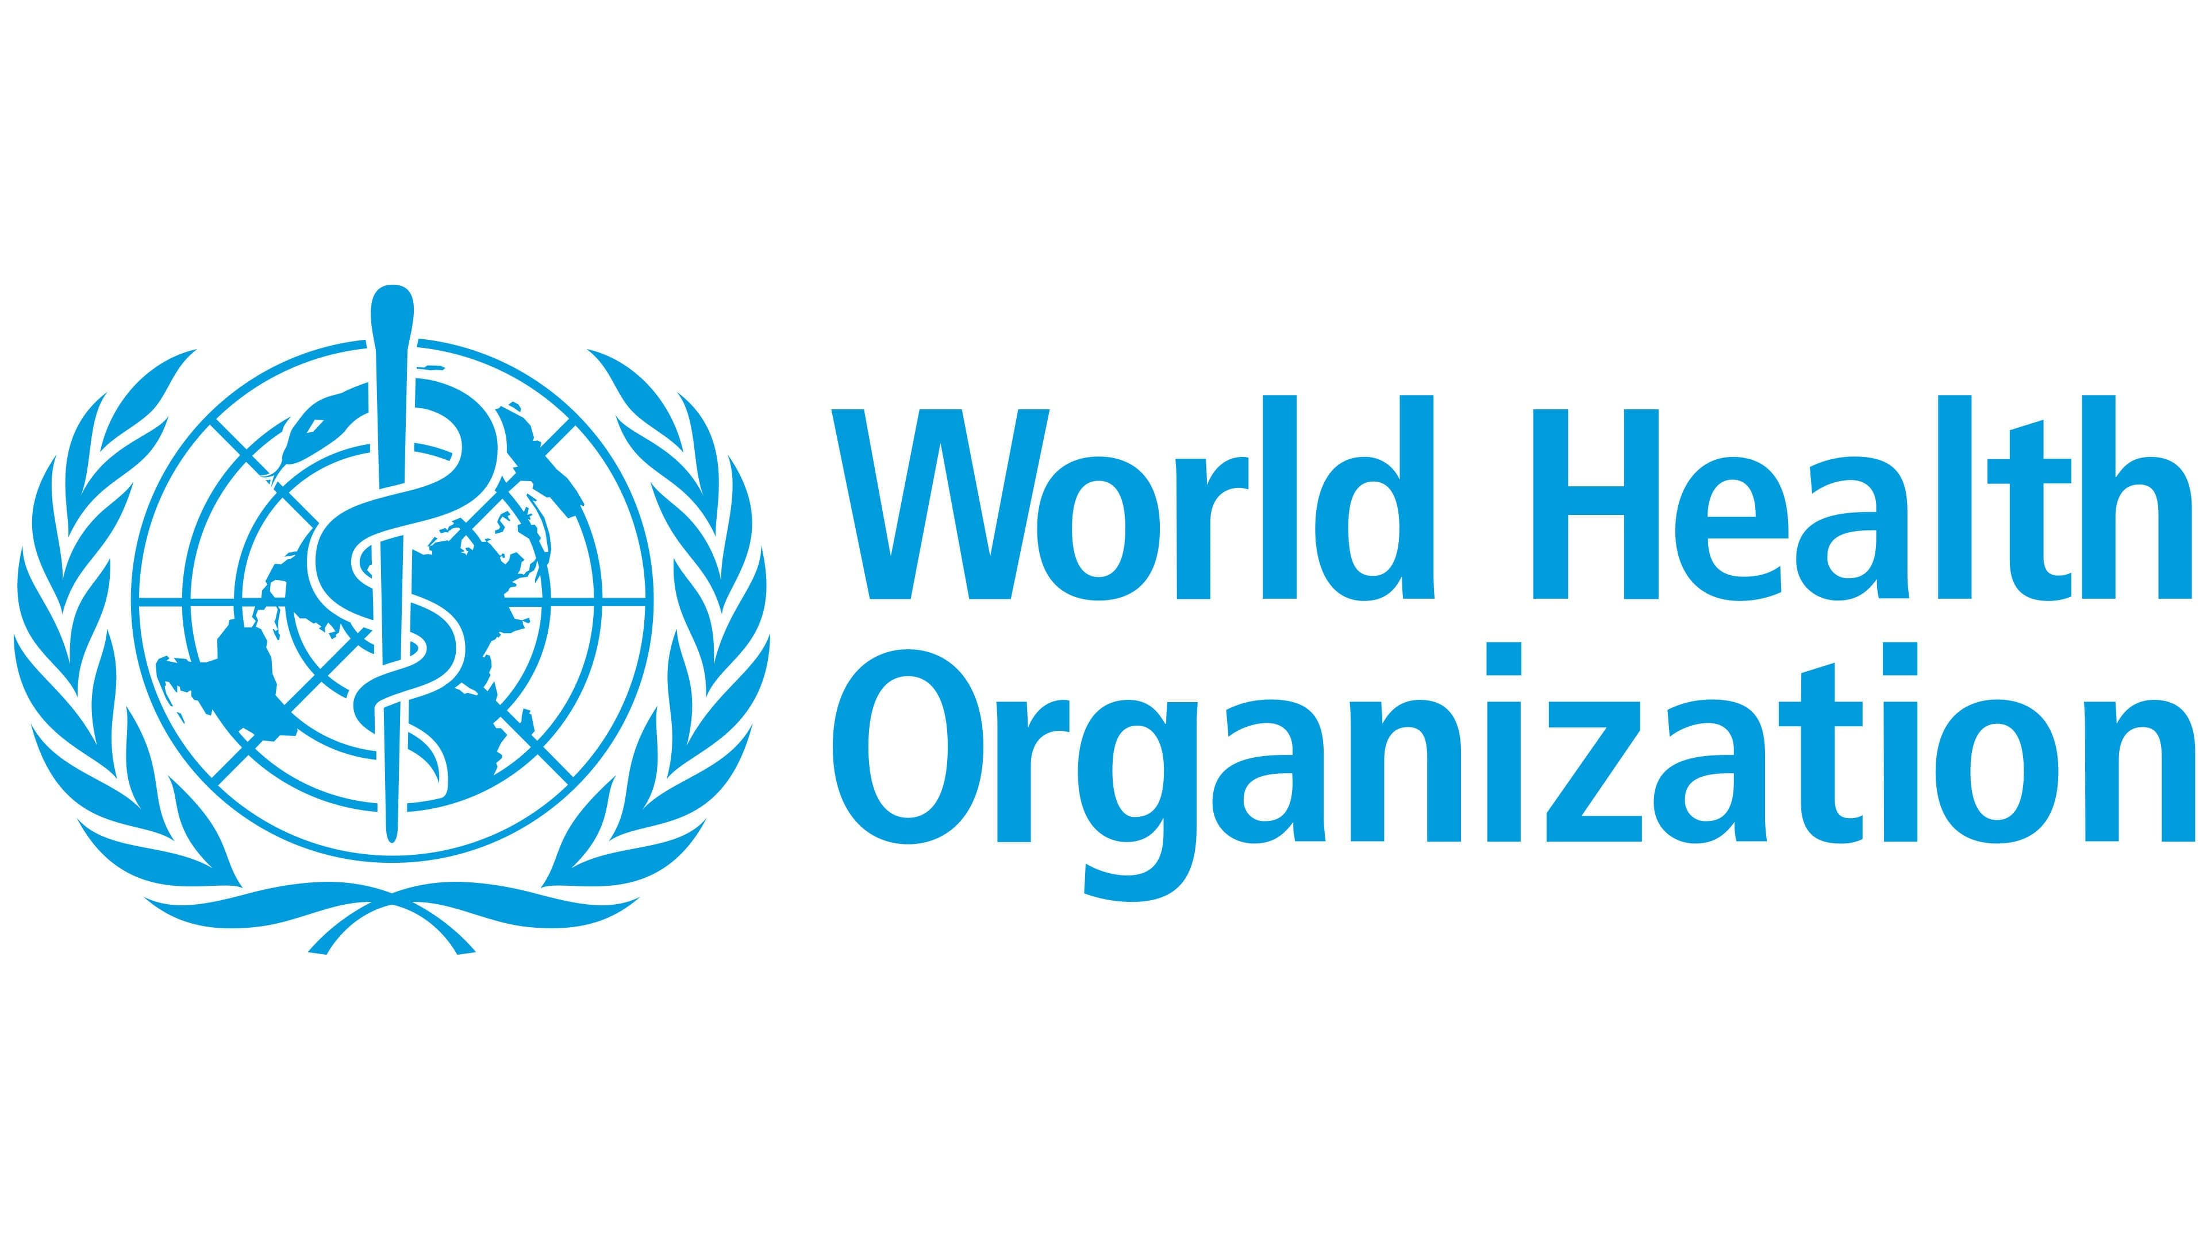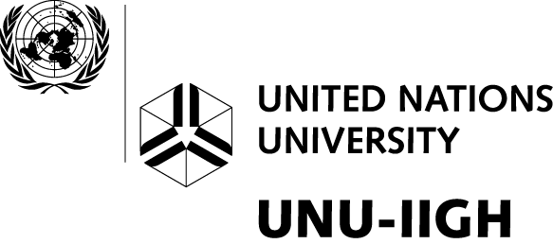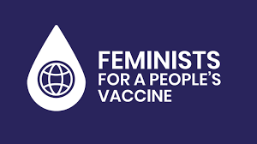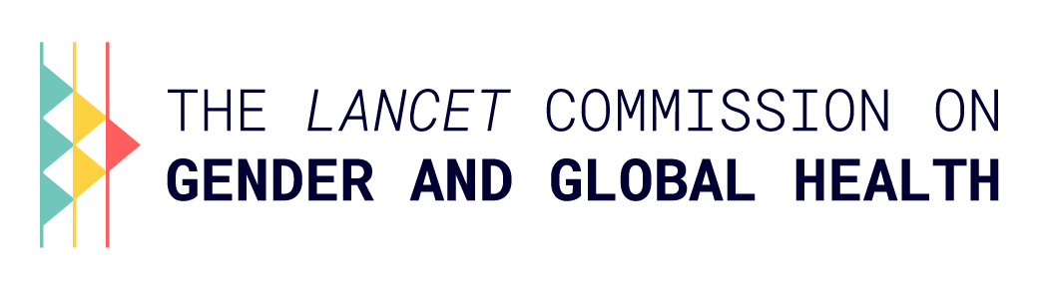

World Health Summit 2022

**Gender Equity in Immunisation and Vaccine Development, deployment, access, and uptake**

Lessons from COVID-19 for future policy pathways

*Roundtable*

**16 October 2022, 2:00 – 3:30 PM (CET)**

**Brazzaville Lounge**

Session description

The development of safe, effective vaccines for COVID-19 disease is a remarkable scientific achievement, which highlighted both what science can achieve, and the barriers that hold back progress. Sex and gender barriers have been observed at all stages of COVID-19 vaccine rollout in relation to vaccine development (e.g. who is included or excluded from clinical trials), vaccine deployment, access and uptake, as well as vaccine hesitancy and intention to take up vaccine when offered or available. The diagnosis is clear, sex and gender inequities limit the success of vaccine rollout and embed injustice in pandemic responses.

The urgency and priority of the global response to COVID-19 has also offered scope to do things differently, learn from experience, and prepare more effectively for ongoing and future vaccine development and deployment. In order to achieve sustainable change, the global health community must consider current successes and failures to chart a way forward that is equitable, actionable and leaves no one behind. In this roundtable discussion, high-level stakeholders from governments, CSOs and donor communities will review the evidence for sex and gender inequity in relation to COVID-19 vaccine development and deployment and highlight the promising practices in addressing these barriers to redress inequities. The discussion will articulate a clear shared policy-relevant and people-centred vision to guide the application of a gender lens to vaccine research, investments, and programming and outline a joint statement of concrete steps for collective action.

Key guiding questions

* To what extent were the sex and gender barriers and inequities observed in COVID-19 vaccine development and deployment? What has worked effectively to address gendered barriers to COVID-19 vaccine uptake?
* What learning does the experience of COVID-19 vaccines offer for a gender informed development and introduction other vaccines – including the introduction of new vaccines? What should be retained, done differently or implemented more widely?
* How can evidence, data and programmatic learning shape the way forward on a gender responsive approach?
* Are there actions that the future architecture for pandemic preparedness should take into account with regard to gender and vaccination?

Proposed co-hosts of session

WHO (confirmed), Lancet Commission on Gender and Global Health (confirmed), Feminists for a People’s Vaccine (confirmed), African Union Commission (interested/in-discussion)

Format

This session will be a 90-minute roundtable discussion bringing together **25-30** high-level experts, representatives from governments, and the global research and funding communities to share/reflect on the experience and evidence to date, and brainstorm and formulate concrete pathways to position gender and equity firmly on the immunisation and pandemic preparedness agenda. The meeting aims to be a kick-off session for continued action-oriented engagement with a core group of change-makers and champions.

Confirmed Participants

* **Ayoade Alakija**, WHO Special Envoy, ACT-A
* **Kate O’Brien**, Director Immunisation, Vaccines, and Biologicals, WHO
* **Soumya Swaminathan**, Chief Scientist, WHO
* **Chee Yoke Ling**, Executive Director, Third World Network; Feminists for a People’s Vaccine
* **Nina Schwalbe**, Principal Visiting Fellow, UNU-IIGH
* **Rajat Khosla**, Director, UNU-IIGH

Outputs

Key messages and recommendations from the session will be compiled in a joint statement for publication and further engagement.

Outcome

* Building multistakeholder alliances for a gender response/gender informed global health architecture
* Articulating a clear shared policy-relevant and people-centred vision to guide the application of a gender lens to vaccine research, investments and programming
* Consolidating and amplifying promising practices in addressing gender and sex-related barriers in vaccine development and deployment.
* Outlining transferable lessons for future efforts on pandemic preparedness with regard to gender and vaccination specifically, what should be retained, done differently or implemented more widely building on the [Guidance note and checklist for tackling gender-related barriers to equitable COVID-19 vaccine deployment](https://www.genderhealthhub.org/articles/guidance-note-and-checklist-for-tackling-gender-related-barriers-to-equitable-covid-19-vaccine-deployment/)